

- Important Information
1.1 | This form is only for transfers from the Honey Living Annuity to another registered long-term insurer
1.2 | Hollard Life Assurance Company Limited (‘The Administrator’) is the underwriter and Administrator of the Honey Living Annuity.
1.3 | Honey Investment Solutions values your privacy. To deliver our services, we and our service providers need to process the personal information you provide in this form. We will treat this information with caution, and we have put reasonable security measures in place to protect it.
1.4 | For unit transfers, the receiving insurer must offer the same unit trust and unit class selection for you to be able to transfer your investment accounts.
1.5 | No initial financial adviser fees can be taken on transfers from the Honey Living Annuity to another insurer living annuity.
1.6 | This transfer out instruction will only be processed when all investment requirements are met, and all required documents are received.
1.7 | All documents can be sent via email to honey@hollardinvestments.co.za.
1.8 | Any instructions received on a public holiday or over a weekend will be processed at the next available working day.
1.9 | Please note: The Administrator will only accept an instruction that has been signed by the investor/authorised person using either a physical “wet” signature or an electronic signature (that has an associated signing audit trail).
- Document Checklist
☐ | Completed transfer out instruction form.
☐ | Customer Due Diligence (CDD)/FICA documents as per the CDD/FICA requirements list available on our website www.honeyinvestments.co.za.
☐ | Completed receiving insurer’s application form
☐ | Proof of the receiving insurer’s South African banking details on the receiving insurer’s letterhead, if you are doing a cash transfer
☐ | Bulk account number(s) on the receiving insurer’s letterhead if you are doing a unit transfer


- Investor Details
3.1 | Investment Number:
 | Investor Name:
 | Investor ID Number
3.2 | Contact Details:
3.2 | Telephone: |  |  | Mobile:
3.2 | Email:
3.2 | Please indicate if these are new contact details? ☐ Yes ☐ No
3.3 | Income Tax Details
3.3 | Income Tax Number*
3.3 | If you do not have an income tax number, please state the reason below:
3.3 | *If you do not provide us with your income tax number and you are registered for tax in South Africa, SARS will decline the tax directive application. This may delay the processing of your instruction.
- Transfer Details
4.1 | Is this a unit Transfer? | ☐ Yes |  | ☐ No (Subject to the rules of the transferring insurer)
4.2 | Details of the Receiving Insurer
4.2 | Name of approved insurer:
4.2 | FSCA fund registration number:
4.2 | SARS approval number:
4.2 | Contact name:
4.2 | Contact telephone number:
4.2 | Contact email address:
4.2 | Reason for the transfer from the Honey Living Annuity?

- Investor Declaration
5.1 | I confirm that all information provided in this form is correct.
5.2 | I understand that a compulsory annuity policy may not be commuted for cash and that the full amount of the investment account will be invested by the transferee insurer.
5.3 | I understand that after the policy has been transferred, the percentage that determines my annuity income payment as well as the frequency of my annuity payment will remain the same as the original policy. I further acknowledge that should I wish to change the percentage or the frequency of my annuity payment, I may only do so on my next policy anniversary date. The policy anniversary date will remain the same as the policy anniversary date of the original investment.
5.4 | I understand that any annual administration fees, financial advisor annual fees and portfolio management fees (where applicable) owed will be deducted from the investment account before the transfer takes place. I further understand that no Financial Advisor initial fees, initial administration fees or initial management fees may be charged on the transfer.
5.5 | I have not received advice from The Administrator in respect of this instruction.
5.6 | I have read and understood the Honey Living Annuity Information Document. This is available from your Financial Services Provider, Honey Investment Solutions Client Service Centre or on the website at www.honeyinvestments.co.za.
5.7 | I give permission to the administrator to send any information or documentation on my behalf to the receiving insurer with regards to this transfer.
5.8 | Signature:
5.8 | 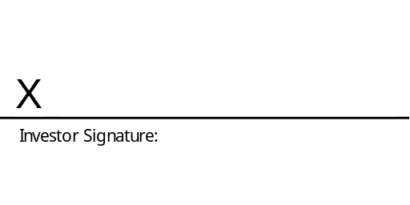
5.8 | Date:
5.8 | Official Capacity:
* If the investor is under the age of 18, this signature must be that of the person acting on behalf of the investor.

