- Important Information
1.1 | Honey Investment Solutions values your privacy. To deliver our services, we and our service providers need to process the personal information you provide in this form. We will treat this information with caution, and we have put reasonable security measures in place to protect it.
1.2 | On death of the Policyholder, the policy will be terminated, and the proceeds paid to the beneficiaries in the proportion specified by the Policyholder prior to his/her death. Each of your Beneficiaries may choose from the following options with regards to their share of the death benefit, subject to the requirements of the relevant authorities and with the agreement of The Administrator:  - The death benefit may be used to purchase a Living Annuity from The Administrator or a living annuity or life annuity from another insurer under the Long-term Insurance Act, No 52 of 1998.  - The death benefit may be paid out as a cash lump sum, where permitted by the relevant authority. Legislation requires that this process take place within 6 months of the death of the Investor.  - The death benefit may be taken as a combination of an annuity purchase and a cash pay-out.
1.2 | - Please note: Should the nominated beneficiary be a juristic person; a purchase of a living annuity is not permitted. The beneficiary may only elect a cash payout.
1.3 | The Administrator will only release payment once all the requirements have been received from all nominated beneficiaries.
1.4 | It is imperative that you familiarise yourself with the Honey Living Annuity Information Document. This is available from your Financial Services Provider, our Client Service Centre or on our website at www.honeyinvestments.co.za.
1.5 | All documents can be sent via email to honey@hollardinvestments.co.za
1.6 | Please note: The Administrator will only accept an application that has been signed by the investor/authorised person using either a physical “wet” signature or an electronic signature (that has an associated signing audit trail).

- Document Checklist
2.1 | Beneficiary Election
2.1 | ☐ | Should the beneficiary(ies) elect to purchase a Honey Living Annuity, a completed Investment Application form available on our website www.honeyinvestments.co.za. Should the beneficiary(ies) elect to purchase a Living Annuity with another provider, a completed application form from the product provider must be provided to The Administrator.
2.1 | ☐ | For Cash Lump sum payments to the beneficiary(ies), please complete all the sections in this form. Proof of Income Tax number must be provided.
2.1 | ☐ | For a combination of a cash lump sum and a purchase of a living annuity, a completed application form from the respective product provider. Please also complete all the sections in this form. Proof of Income Tax number must be provided.
2.2 | Applicable to all Beneficiaries:
2.2 | ☐ | Customer Due Diligence (CDD)/FICA documents as per the CDD/FICA requirements list available on our website www.honeyinvestments.co.za.
2.2 | ☐ | Proof of banking details for the respective beneficiary/ies, not older than 3 months.
2.2 | ☐ | A certified copy of the death certificate and identity document for the deceased life assured.
2.2 | Additional documents for the different beneficiary types are listed below. These are required over and above the list specified in 2.2 above.
2.3 | Trust Beneficiary:
2.3 | ☐ | Customer Due Diligence (CDD)/FICA documents as per the CDD/FICA requirements list available our website www.honeyinvestments.co.za.
2.3 | ☐ | Certified copy of the Letter of Authority.
2.4 | Legal Entity Beneficiary:
2.4 | ☐ | A certified copy of Letter of Authority/Company Resolution.
2.5 | Estate Beneficiary
2.5 | ☐ | Copy of the Letters of Executorship, certified by a commissioner or verified by the Financial Services Provider.

- Policyholder Details
Policy Number:
Policyholder Name:
Identity Number:
- Beneficiary Election
- Please select the death benefit option that the beneficiary(ies) wish to exercise by ticking the box next to the election option and entering the beneficiary name and surname.
- Should the nominated beneficiary be a juristic person; a purchase of a living annuity is not permitted. The beneficiary may only elect a cash payout.
Option Election | Beneficiary One:  Name and Surname | Beneficiary Two:  Name and Surname | Beneficiary Three:  Name and Surname | Beneficiary Four:  Name and Surname
Cash Payout for full death benefit | ☐ | ☐ | ☐ | ☐
Purchase of a Living Annuity with full death benefit | ☐ | ☐ | ☐ | ☐
Combination of Cash Payout and Living Annuity Purchase | ☐ | ☐ | ☐ | ☐
- Beneficiary Details for Cash Payments
Please note: The Administrator does not pay benefits to offshore bank accounts.
5.1 | Natural Person Beneficiary/Beneficiaries for Proceeds:
5.1 | 1st Beneficiary:
5.1 | If a partial cash payment is required, please provide required cash amount (The remaining amount will be used to purchase a living annuity): |  | R
5.1 | Full Name & Surname:
5.1 | ID Number:
5.1 | Relationship to deceased

Contact Number:
Residential Address
Bank Details:
 | Account Holder:
 | Bank Name: |  |  | Branch Name:
 | Account Number: |  |  | Code:
 | Account Type: ☐ Savings ☐ Cheque/Current ☐ Transmission ☐ Other
 | Income Tax Number:
 | 2nd Beneficiary:
 | If a partial cash payment is required, please provide required cash amount (The remaining amount will be used to purchase a living annuity): |  | R
 | Full Name & Surname:
 | ID Number:
 | Relationship to deceased
 | Contact Number:
 | Residential Address
 | Bank Details:
 | Account Holder:
 | Bank Name: |  |  | Branch Name:
 | Account Number: |  |  | Code:
 | Account Type: ☐ Savings ☐ Cheque/Current ☐ Transmission ☐ Other
 | Income Tax Number:
 | 3rd Beneficiary:
 | If a partial cash payment is required, please provide required cash amount (The remaining amount will be used to purchase a living annuity): |  | R
 | Full Name & Surname:
 | ID Number:
 | Relationship to deceased
 | Contact Number:
 | Residential Address

Banking Details:
 | Account Holder:
 | Bank Name: |  |  | Branch Name:
 | Account Number: |  |  | Code:
 | Account Type: ☐ Savings ☐ Cheque/Current ☐ Transmission ☐ Other
 | Income Tax Number:
 | 4th Beneficiary:
 | If a partial cash payment is required, please provide required cash amount (The remaining amount will be used to purchase a living annuity): |  | R
 | Full Name & Surname:
 | ID Number:
 | Relationship to deceased
 | Contact Number:
 | Residential Address
 | Banking Details:
 | Account Holder:
 | Bank Name: |  |  |  |  |  |  | Branch Name:
 | Account Number: |  |  |  |  |  |  | Code:
 | Account Type: ☐ Savings ☐ Cheque/Current ☐ Transmission ☐ Other
 | Income Tax Number:
5.2 | Trust Beneficiary for Proceeds:
5.2 | Name of Trust:
5.2 | Residential Address
5.2 | Contact Number
5.2 | Trust Number:
5.2 | Trust Representative Name:
5.2 | Banking details:
5.2 | Account Holder:
5.2 | Bank Name: |  |  |  |  |  | Branch Name:
5.2 | Account Number: |  |  |  |  |  | Code:
5.2 | Account Type: ☐ Savings ☐ Cheque/Current ☐ Transmission ☐ Other
5.2 | Income Tax Number:

5.3 | Legal Entity Beneficiary for Proceeds:
5.3 | Name of Entity:
5.3 | Residential Address:
5.3 | Contact Number:
5.3 | Reg. Number:
5.3 | Legal Entity Representative name:
5.3 | Banking Details:
5.3 | Account Holder:
5.3 | Bank Name: |  |  |  |  | Branch Name:
5.3 | Account Number: |  |  |  |  | Code:
5.3 | Account Type: ☐ Savings ☐ Cheque/Current ☐ Transmission ☐ Other
5.3 | Income Tax Number
5.4 | Estate Beneficiary
5.4 | Executor Name:
5.4 | Executor ID Number:
5.4 | Residential Address
5.4 | Contact Number
5.4 | Account Holder:
5.4 | Bank Name: |  |  |  |  |  | Branch Name:
5.4 | Account Number: |  |  |  |  |  | Code:
5.4 | Account Type: ☐ Savings ☐ Cheque/Current ☐ Transmission ☐ Other
5.4 | Income Tax Number
- Beneficiary Declaration
6.1 | I/We, the beneficiaries named herein understand that the amount payable shall be determined in accordance with the Policy Conditions.
6.2 | I/We further understand that any fees and charges payable, will continue to be deducted until such time that the death claim has been processed.
6.3 | I/We declare that, to the best of my/ our knowledge and belief, the information given herein is true and complete.
6.4 | I/We acknowledge that The Administrator reserves the right to revert for further requirements if required.

6.5 | I/We acknowledge that The Administrator will only disinvest the underlying portfolios from the asset manager when all requirements for the death claim has been received and processed. The Administrator is subject to liquidity, trading/notice periods for asset managers.
6.6 | I/We acknowledge and agree that all electronic representations of all documents, including this form, and any other instructions hereafter, including mandates, consents, commitments and the like, which purport to emanate from me/us, shall be deemed to have been given by me/us in the form actually received by The Administrator. I/we hereby waive any rights I/we may have or may obtain against The Administrator arising directly or indirectly from any losses or damages that I/we may suffer because The Administrator acted on any purported electronic representations, and I/we indemnify The Administrator against any claims, demands or actions suffered by them because they acted on an electronic representation.
6.7 | I/We confirm that I/we have signed this declaration of my/our own free will and I/we regard it as binding.
6.8 | Natural Person Beneficiaries Signatures:
6.8 | 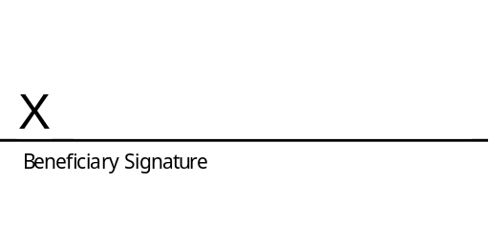
6.8 | Date: |  |  | Date:
6.8 | Date: |  |  | Date:
6.8 | Executor Signatures:
6.8 | 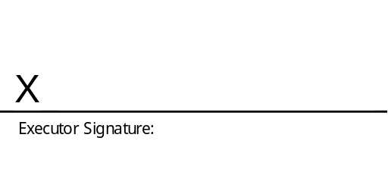
6.8 | Date:

 | Trust Beneficiaries:
 | 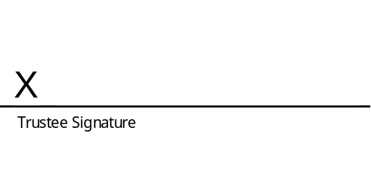
 | Date: |  | Date:
 | Date: |  | Date:
 | Legal Entity Beneficiaries:
 | 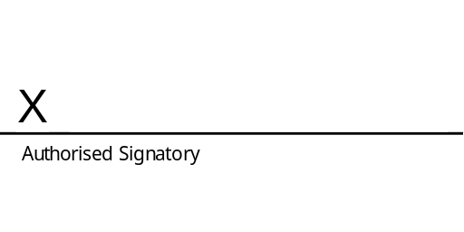
 | Date: |  | Date:
 | Date: |  | Date:

