

- Important Information
1.1 | Hollard Life Assurance Company Limited (‘The Administrator’) is the underwriter and Administrator of the Honey Living Annuity.
1.2 | Honey Investment Solutions values your privacy. To deliver our services, we and our service providers need to process the personal information you provide in this form. We will treat this information with caution, and we have put reasonable security measures in place to protect it.
1.3 | You may only withdraw from a Living Annuity if the market value is less than/equal to R150 000.
1.4 | A request to withdraw from your policy will result in the full withdrawal of the value of the investment account and the policy will cease.
1.5 | This withdrawal instruction will only be processed when all investment requirements are met and all required documents are received.
1.6 | All documents can be sent via email to honey@hollardinvestments.co.za.
1.7 | The daily cut-off for receipt of instructions is 14H00.
1.8 | Any instructions received on a public holiday or over a weekend will be processed at the next available working day.
1.9 | Please note: The Administrator will only accept an application that has been signed by the investor/authorised person using either a physical “wet” signature or an electronic signature (that has an associated signing audit trail).

- Document Checklist
☐ | Completed Withdrawal Form.
☐ | Customer Due Diligence (CDD)/FICA documents as per the CDD/FICA requirements list available on our website www.honeyinvestments.co.za.  Please note: FICA documents are required for all related parties to the policyholder (i.e. nominated beneficiaries; and any other authorised persons)
☐ | Proof of banking details if not already provided (or bank statement not older than 3 months).
- Investor Details
3.1 | Investment Number:
 | Investor Name:

 | Investor ID Number
3.2 | Contact Details:
3.2 | Telephone: |  | Mobile:
3.2 | Email:
3.2 | Please indicate if these are new contact details? ☐ Yes ☐ No
- Investor Bank Account Details
Please complete this section only if the banking details specified on your original investment application have changed.
4.1 | Payments to third party bank accounts are not allowed. Payment will only be made to a bank account in your name.
4.2 | No payments will be made to offshore bank account, credit cards or market linked accounts.
4.3 | Banking Details
Account Holder:
Bank Name: |  |  | Branch Name:
Account Number: |  |  | Code:
Account Type: |  | ☐ Savings ☐ Cheque/Current ☐ Transmission ☐ Other
- Investor Declaration
5.1 | I confirm that all information provided in this form is correct.
5.2 | I authorise the payment of the proceeds as per the instruction and applicable legislation.
5.3 | I have not received advice from The Administrator in respect of this instruction.
5.4 | I have read and understood the Honey Living Annuity Information Document. This is available from your Financial Services Provider, the Client Service Centre or on the website at www.honeyinvestments.co.za.
5.5 | Signature:
5.5 | 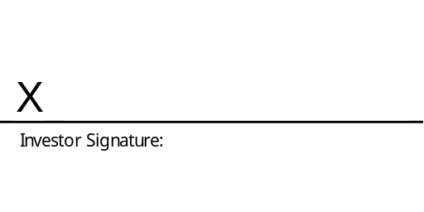
5.5 | Date:
5.5 | Official Capacity:
* If the investor is under the age of 18, this signature must be that of the person acting on behalf of the investor.

