

- Important Information
1.1 | Hollard Life Assurance Company Limited (‘The Administrator’) is the underwriter and Administrator of the Honey Living Annuity
1.2 | Honey Investment Solutions values your privacy. To deliver our services, we and our service providers need to process the personal information you provide in this form. We will treat this information with caution, and we have put reasonable security measures in place to protect it
1.3 | All documents can be sent via email to honey@hollardinvestments.co.za
1.4 | Please note: The Administrator will only accept an instruction that has been signed by the investor/authorised person using either a physical “wet” signature or an electronic signature (that has an associated signing audit trail).

- Document Check List
☐ | Completed Annual Revision Notification From.
☐ | Proof of banking details if not already provided (bank statement not older than 3 months).
- Investor Details
3.1 | Investment Number:
 | Investor Name:
 | Investor ID Number
3.2 | Contact Details:
3.2 | Telephone: |  | Mobile
3.2 | Email:
3.2 | Please indicate if these are new contact details? ☐ Yes ☐ No
- Annuity Details
4.1 | This form must be completed and submitted to The Administrator by no later than the date stipulated on the Annuity Review Notification Letter that you would have received from The Administrator
4.2 | The annual annuity income completed below will replace your previous selection and will be effective from your upcoming anniversary date.

4.3 | The pre-tax annuity income is subject to a minimum of 2.5% per year and a maximum of 17.5% per year. These limits are determined by legislation and are subject to change.
4.4 | Revised Payment Frequency:
4.4 | Please select your required payment frequency: ☐ Monthly ☐ Quarterly ☐ Bi-Annually ☐ Annually
4.5 | Revised Annual Annuity Income:
4.5 | Please indicate the level of annual income required, by completing one option below.
4.5 | Percentage Income Required: | % | OR |  | *R
4.5 | *(This should be a minimum of 2.5% and a maximum of 17.5% of the investment value)
4.6 | Annual Income Tax Rate:
4.6 | Do you want to specify an income tax rate? ☐ Yes
4.6 | If Yes, please specify the percentage to be deducted: |  | %
4.6 | If you are specifying a tax rate below the prevailing tax tables, please provide The Administrator with a tax directive to this effect. The directive is valid for the period stated on it. You may renew this by applying to SARS. In the absence of a valid tax directive, the published prevailing tax tables will apply or a tax rate as specified by SARS for a Policyholder. You may specify a higher tax rate if required (no tax directive required).
- Investor Bank Account Details
5.1 | Please complete this section only if the banking details specified on your original investment application have changed.
5.2 | Payments to third party bank accounts are not allowed. Payment will only be made to a bank account in your name.
5.3 | No payments will be made to offshore bank account, credit cards or market linked accounts.
Banking Details:
Account Holder:
Bank Name: |  |  | Branch Name:
Account Number: |  |  | Code:
Account Type: ☐ Savings ☐ Cheque/Current ☐ Transmission ☐ Other

- Investor Declaration
6.1 | I confirm that all information provided in this form is correct.
6.2 | I have not received advice from The Administrator in respect of this application.

6.3 | I understand and accept all risks associated with this investment. In addition, I confirm that I have read and understood all relevant documentation associated with this investment.
6.4 | I have read and understood the Honey Living Annuity Information Document. This is available from your Financial Services Provider, the Honey Investment Solutions Client Service Centre or on the website at www.honeyinvestments.co.za.
6.5 | Signature:
6.5 | 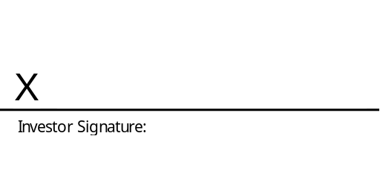
6.5 | Date:
6.5 | Official Capacity:

