
Important Information
1.1 | When making an additional contribution into your policy you, may select to invest in an investment portfolio made available to the product, as confirmed in the investment product portfolio list available on our website www.honeyinvestments.co.za.
1.2 | Honey Investment Solutions values your privacy. To deliver our services, we and our service providers need to process the personal information you provide in this form. We will treat this information with caution, and we have put reasonable security measures in place to protect it.
1.3 | Hollard Life Assurance Company Limited (‘The Administrator’) is the underwriter and Administrator of the Honey Living Annuity.
1.4 | You may not transfer benefits from a guaranteed life annuity to the Honey Living Annuity.
1.5 | For an additional contribution into your Policy, an Effective Annual Cost (EAC) Disclosure may be requested from our Customer Care team on 0860 202 202 or honey@hollardinvestments.co.za.
1.6 | After making an additional contribution the percentage that determines your annuity income payment as well as the frequency of your payment will remain the same as the original policy. If you wish to change the percentage or the frequency of your annuity payment, you may do so on your next policy anniversary date. The policy anniversary date will remain the same as the policy anniversary date of the original investment.
1.7 | All the terms and conditions applicable to your existing Honey Living Annuity will be applicable to this additional contribution.
1.8 | This application will only be processed when all investment requirements are met and once funds reflect in the product bank account.
1.9 | All documents can be sent via email to honey@hollardinvestments.co.za.
1.10 | The daily cut-off for receipt of instructions is 14h00.
1.11 | Any instructions received on a public holiday or over a weekend will be processed at the next available working day.
1.12 | If you are requesting a unit transfer please ensure that:  - The rules of the transferring fund/insurer allow for such a transaction.  - The underlying investment portfolios you select and their classes are available from The Administrator at the time of the transfer. If not, you must switch into an available investment portfolio and class before the transfer is completed. Please arrange this with your current fund/insurer.
1.13 | Please note: The Administrator will only accept an application that has been signed by the investor/authorised person using either a physical “wet” signature or an electronic signature (that has an associated signing audit trail).



Document Checklist
Please to include all of the below documents:
☐ | Completed additional contribution form.
☐ | Customer Due Diligence (CDD)/FICA documents as per the CDD/FICA requirements list available on our website www.honeyinvestments.co.za.  Please note: FICA documents are required for all related parties to the policyholder (i.e. nominated beneficiaries; and any other authorised persons).
☐ | For a transfer, a recent statement of your investment from the transferring administrator.
☐ | For a model portfolio investment, a completed Client Mandate must be provided. The Client Mandate is available from your Financial Advisor.
☐ | Completed Investor Declaration (see the last section of this form) should you choose to invest into one or more Qualified Investor Hedge Funds.
Investor Details
3.1 | Investment Number:
 | Investor Name:
3.2 | Contact Details:
3.2 | Telephone: |  | Mobile:
3.2 | Email:
3.2 | Please indicate if these are new contact details? ☐ Yes ☐ No
Investment Details
4.1 | Is this a Unit Transfer? ☐ Yes
4.2 | Invest initiated by means of:  - ☐ New Investment (Upon Retirement)  - ☐ Transfer from another administrator (Select only ONE)
4.3 | Estimated Investments Value Amount: | R

4.4 | Transfer Details:  In the event of multiple transfers, amounts will be invested as and when they are received by The administrator, provided all requirements have been met.
4.4 |  | Registered Name of Source Fund/Insurer | Policy Number
4.4 | Transfer 1
4.4 | Transfer 2
4.4 | Transfer 3
4.5 | Income and Expense Account:  You can choose to have your annual administration fee, Financial Advisor annual fee and your annuity payments deducted from a nominated expense account, designated as the Hollard BCI Money Market Fund.  Do you require an Income and Expense Account? ☐ Yes  If Yes, please ensure to select the Hollard BCI Money Market Fund as one of your underlying investment portfolios.  If the Income and Expense account does not have sufficient funds at the time that annual fees and annuity payments are deducted, annual fees and annuity payments will be deducted proportionally from the remaining investment portfolios in the investment account.
4.6 | If you are investing in a model portfolio, please provide the model portfolio name in the table below (and not the names of the investment portfolios in which the model portfolio invests). You may invest in one or a combination of investment portfolios and/or model portfolios.
4.6 | Investment/Model Portfolio Name |  |  | Percentage
4.6 |  |  |  | %
4.6 |  |  |  | %
4.6 |  |  |  | %
4.6 |  |  |  | %
4.6 |  |  |  | %
4.6 |  |  |  | %
4.6 |  |  |  | %
Total |  |  |  | 100%

Financial Service Provider (FSP) Details and Declaration
Practice Name (FSP): |  |  |  | FSP Number:
Financial Advisor Name: |  |  |  | Financial Advisor Code:
Please select an initial fee that will apply to this instruction. If a fee is not specified, a zero-initial fee will be applied.
Initial Fee: |  | % | (Financial Advisor Initial Fee may not exceed 1.5% excl.VAT)
Signature:
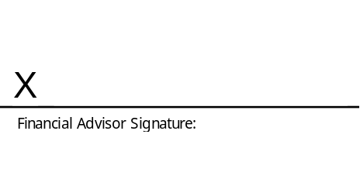 |  |  |  | 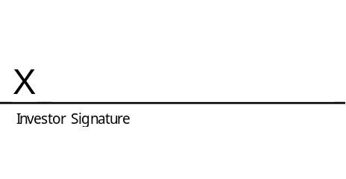
Date: |  |  |  | Date:
- Investor Declaration
6.1 | I confirm that all information provided in this form is correct.
6.2 | I have not received advice from The Administrator in respect of this application.
6.3 | I understand and accept all risks associated with this investment. In addition, I confirm that I have read and understood all relevant documentation associated with this investment.
6.4 | I have read and understood the Honey Living Annuity Information Document. This is available from your Financial Services Provider, the our Client Service Centre or on our website at www.honeyinvestments.co.za.
6.5 | Signature:
6.5 | 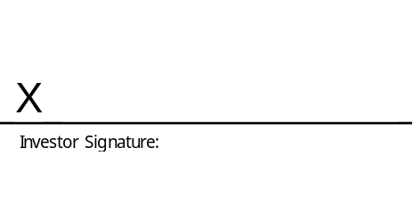
6.5 | Date:

Qualified Investor Hedge Fund Declaration
7.1 | The South African Hedge Fund industry is now subject to legislation which regulates the Funds under the Collective Investment Schemes Control Act 45 of 2002. The regulations are intended to provide a greater level of protection and certainty for investors. The legislation allows for two categories of Hedge Funds: A Retail Investor Hedge Fund, and a Qualified Investor Hedge Fund. Each Hedge Fund is registered as one of these categories.
7.2 | A Retail Investor Hedge Fund is intended to be marketed to a broader retail market. As such these funds are subject to more stringent legislation regarding transacting frequency, levels of leverage, underlying investment instruments and risk management, amongst other things.
7.3 | A Qualified Investor Hedge Fund is intended for a more technically astute investor and is subject to less stringent limitations. Qualified Investors or their Financial Advisors should have demonstrable knowledge and experience which enables them to assess the merits and risks of a Qualified Hedge Fund investment.
7.4 | You have chosen to invest into one or more Qualified Investor Hedge Funds within your policy, and we therefore require that you complete the below declaration.
7.4 | ☐ | I/We confirm that I/We am aware that I/We am investing into one or more Qualified Investor Hedge Funds within my policy.
7.4 | ☐ | I/We confirm that my/our appointed financial advisor has demonstrable knowledge and experience to advise me/us regarding the merits and risks of a Qualified Investor Hedge fund investment. My financial advisor has explained this investment to me/us. I/We confirm that I/We understand the nature and risks of the investment I/We am making. I/We acknowledge the inherent risk associated with the selected Hedge Fund(s) and understand that there are no performance guarantees.
7.4 | OR
7.4 | ☐ | I/We confirm that I/We have the required demonstrable knowledge and experience in financial and investment matters to assess and select this investment in a Qualified Investor Hedge Fund. I/We confirm that I/We understand the nature and risks of the investment I am making. I/We acknowledge the inherent risk associated with the selected Hedge Fund(s) and understand that there are no performance guarantees.
7.5 | Signature:
7.5 |  |  | Official Capacity:
7.5 |  |  | Date:

