

- Important Information
1.1 | Honey Investment Solutions values your privacy. To deliver our services, we and our service providers need to process the personal information you provide in this form. We will treat this information with caution, and we have put reasonable security measures in place to protect it.
1.2 | All documents must be sent by email to honey@hollardinvestments.co.za.
1.3 | Please note: The Administrator will only accept an application that has been signed by the investor or duly authorised person using either a physical “wet” signature or an electronic signature (that has an associated signing audit trail).
- Investor Details
Investor Name:
Identity/Passport/Reg Number:
Investment Number:
- Third Party Details – Natural Persons
3.1 | Personal Details:
3.1 | Title:
3.1 | Full Name & Surname:
3.1 | ID/Passport No: |  |  |  |  |  |  |  | Date of Birth:
3.2 | Address Details
3.2 | Residential Address:
3.2 | Complex Name: |  |  |  |  |  |  |  |  |  | Unit No:
3.2 | Street/Farm Name: |  |  |  |  |  |  |  |  |  | Street No:
3.2 | Suburb/District:
3.2 | City/Town: |  |  |  |  |  |  |  |  |  |  | Code:
3.2 | Postal Address:
3.2 | Postal address same as residential address? |  |  |  |  | ☐ Yes |  | ☐ No |  | If No, please complete details below?
3.2 | Address Type: | ☐ PO Box |  |  | ☐ Private Bag |  | ☐ Postnet Suit |  |  | ☐ Box/Bag/Suite No:
3.2 | Post Office Name: |  |  |  |  |  |  |  |  |  |  | Code:

3.3 | Contact Details:
3.3 | Tel: |  | Mobile:
3.3 | Email:
- Third Party Details – Legal Entities
4.1 | Entity Details:
4.1 | Registered Name of Entity:
4.1 | Registration Number:
4.2 | Address Details
4.2 | Registered Address:
4.2 | Complex Name: |  |  |  |  |  |  |  |  | Unit No:
4.2 | Street/Farm Name: |  |  |  |  |  |  |  |  | Street No:
4.2 | Suburb/District:
4.2 | City/Town: |  |  |  |  |  |  |  |  |  | Code:
4.2 | Postal Address:
4.2 | Postal address same as residential address? ☐ Yes ☐ No If No, please complete details below?
4.2 | Address Type: | ☐ PO Box |  |  |  | ☐ Private Bag | ☐ Postnet Suit |  | ☐ Box/Bag/Suite No:
4.2 | Post Office Name: |  |  |  |  |  |  |  |  |  | Code:
4.3 | Contact Details:
4.3 | Contact Person:
4.3 | Tel: |  |  |  |  |  | Mobile:
4.3 | Email:
- Banking Details for Withdrawal Proceeds
5.1 | In terms of FICA legislation, The Administrator must identify and verify the third party.
5.2 | The following FICA documentation must be attached to this Third Party Payment Indemnity Form for the owner of the 3rd party bank account:
5.2 | - Copy of a South African green bar-coded ID/new smart ID or valid passport, with photograph and legible text.
5.2 | - Copy of Utility Bill reflecting the physical address details (not older than 3 months).
5.2 | - Proof of banking details (cancelled cheque or bank statement, not older than 3 months).

 | - If the third part is a legal entity, please provide FICA documents as per the FICA requirements list on our website www.honeyinvestments.co.za
5.3 | Banking Details
5.3 | Bank Name: |  |  | Branch Name:
5.3 | Account Holder:
5.3 | Account Number: |  |  | Branch Code:
5.3 | Account Type: | ☐ Transmission ☐ Cheque/Current ☐ Savings ☐ Other:
- Indemnity and Disclaimer
6.1 | I/we confirm that the bank account, to which I/we have requested the withdrawal proceeds be paid, is considered by The Administrator as being a third party account and I/we have been advised by The Administrator that this is not normal procedure.
6.2 | I/we indemnify The Administrator against all and any claims that could be made by me/us or by the legal owner of the bank account in question if, after the proceeds have been paid to the requested third party account, I conclude that to have been an erroneous decision.
6.3 | I/we further indemnify The Administrator against all and any losses that I/we, or the legal owner of the third party account, may suffer as a result of the transfer being made, by The Administrator, thereto.
6.4 | I/we acknowledge that The Administrator reserves the right in its sole discretion to decline to make payment into any account other than a bank account of the Investor.
6.5 | I/we acknowledge that this third party payment will solely apply to the above mentioned transaction.
6.6 | I confirm that I have read and completed this declaration, whether in my own handwriting or not, and that I understand the implications hereof.
6.7 | Signature
6.7 | 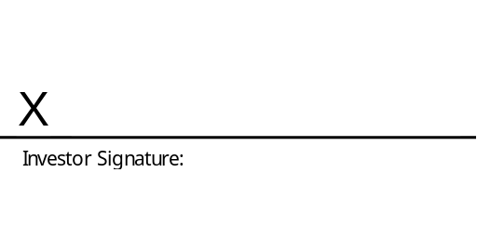 |  | 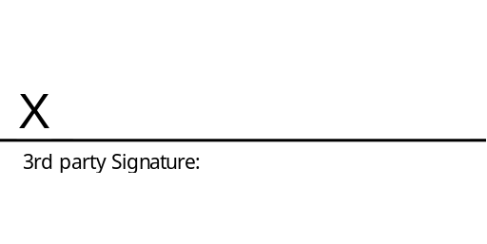
6.7 | Name: |  | Name:
 | Date: |  | Date:

