

- Important Information
1.1 | Honey Investment Solutions values your privacy. To deliver our services, we and our service providers need to process the personal information you provide in this form. We will treat this information with caution, and we have put reasonable security measures in place to protect it.
1.2 | This Customer Due Diligence (CDD) Declaration must be completed and signed by an authorised person(s) of the legal entity person using either a physical “wet” signature or an electronic signature (that has an associated signing audit trail). This declaration serves to confirm that the FICA documentation held by The Administrator is still valid at the time of signing this declaration.
1.3 | Should we not receive the completed declaration from you by the required date as confirmed by our Client Services Team, your investment account(s) will be blocked from performing any further transactions. In addition, a new set of FICA documents will need to be provided to us before the investment account is unblocked.
1.4 | Should any information provided in this declaration differ from the information we have on record, we may request additional documentation from you.
1.5 | All documents must be sent by email to honey@hollardinvestments.co.za.

- Document Checklist
☐ | Updated Company Resolution / letter of authority.
☐ | Identity document and proof of residence (not older than 3 months) for any new persons(s) added to the company resolution previously provided to The Administrator.
- Identification of Investor
3.1 | Entity Details:
3.1 | Registered Name of Entity:
3.1 | Registration Number:
3.1 | Investor Number:
3.2 | Address Details
3.2 | Registered Address:
3.2 | Complex Name: |  |  | Unit No:
3.2 | Street/Farm Name: |  |  | Street No:
3.2 | Suburb/District:
3.2 | City/Town: |  |  | Code:

 | Postal Address:
 | Postal address same as residential address? ☐ Yes ☐ No If No, please complete details below?
 | Address Type: | ☐ PO Box |  | ☐ Private Bag | ☐ Postnet Suite |  | ☐ Box/Bag/Suite No:
 | Post Office Name: |  |  |  |  |  |  | Code:
3.3 | Contact Details:
3.3 | Contact Person
3.3 | Tel: |  |  |  | Mobile:
3.3 | Email:
- Details of Person Completing this Form
4.1 | Personal Details:
4.1 | Title:
4.1 | Full Name & Surname:
4.1 | ID/Passport No: |  |  |  |  | Date of Birth:
4.1 | Capacity
4.2 | Contact Details:
4.2 | Tel: |  |  | Mobile:
4.2 | Email:
- Authorised/Controlling Persons of the Entity

Please provide the name(s) of the authorised/controlling person(s) of the legal entity in the table below and attach a company resolution to this effect.
First name(s) | Surname | Identification Number | Email Address

- Ownership Structure for Corporate Investors

Please detail the individual shareholders and corporate shareholders for the entity and their respective shareholding percentage.
Shareholder Name |  |  | Identification / Registration Number | % Shareholding

I confirm that the ownership structure of the above corporate shareholders remains the same as per the shareholder certificate previously provided to The Administrator.
Yes | ☐
No | ☐ | If no, please provide the updated Share Register to The Administrator
- Beneficiaries and Trustees for Trust Investors

Please provide the name(s) of the Trustees and Beneficiaries (named and unnamed) for the trust
- Beneficiaries
First name(s) | Surname | Identification Number | Type  (Capital or Income)

- Trustees
First name(s) | Surname | Identification Number
- Investor Declaration
I, the undersigned:
8.1 | I am authorised to sign this document on behalf of the entity and declare that all statements made in this declaration are, to the best of my knowledge and belief, correct and complete.
8.2 | Undertake to immediately advise of any change in circumstances which affects the FICA status of the entity.
8.3 | Undertake to immediately advise of any change in details (e.g. current physical address, postal address, authorised persons etc.) of the legal entity and provide The Administrator with updated FICA documents accordingly.
8.4 | Understand that should The Administrator not be provided with valid FICA documents, as listed in the CDD/FICA requirements list available on the Honey Investment Solutions website, that the investment accounts I hold with The Administrator will be blocked for any further transactions I wish to perform.
8.5 | Signature
8.5 | 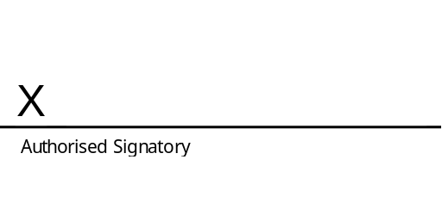
8.5 | Name: |  | Name:
8.5 | Date: |  | Date:

