

Important Information
1.1 | Honey Investment Solutions values your privacy. To deliver our services, we and our service providers need to process the personal information you provide in this form. We will treat this information with caution, and we have put reasonable security measures in place to protect it.
1.2 | All documents must be sent by email to honey@hollardinvestments.co.za.
1.3 | The person completing this declaration must provide a copy of their Identity document and proof of residential address not older than 3-months.
1.4 | Please note: The Administrator will only accept an application that has been signed by the investor or duly authorised person using either a physical “wet” signature or an electronic signature (that has an associated signing audit trail).
Resident / Property Owner Details
I, |  | Full name & surname:
Identity number:
confirm that:
a. | ☐ |  | I own the property located at:
a. | Complex Name: |  |  |  |  | Unit No:
a. | Street/Farm Name: |  |  |  |  | Street No:
a. | Suburb/District:
a. | City/Town: |  |  |  |  | Code:
OR
b. | ☐ |  | I reside at the property located at:
b. | Complex Name: |  |  |  |  | Unit No:
b. | Street/Farm Name: |  |  |  |  | Street No:
b. | Suburb/District:
b. | City/Town: |  |  |  |  | Code:
Cohabitant’s Details & Declaration
I confirm that:
Applicant name & surname:
Identity number:

Relationship to Applicant:
resides at the above-mentioned address noted in section 2.
I have attached a copy of my proof of residential address document which reflects my name and residential address.
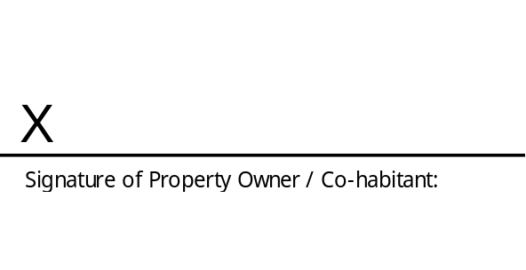
Name:
Date:

